DAD-220 Lab: Table Joins

By Stephen Johnson

The following screenshots (a through h) were taken while updating the table name, inserting records to the department table, performing joins between tables, populating the employee table, performing a join across employee/department tables, and creating a CSV file.

(a)

After changing the permissions of the Codio file, here is a display of the employees list and tables that were created previously.

(b)

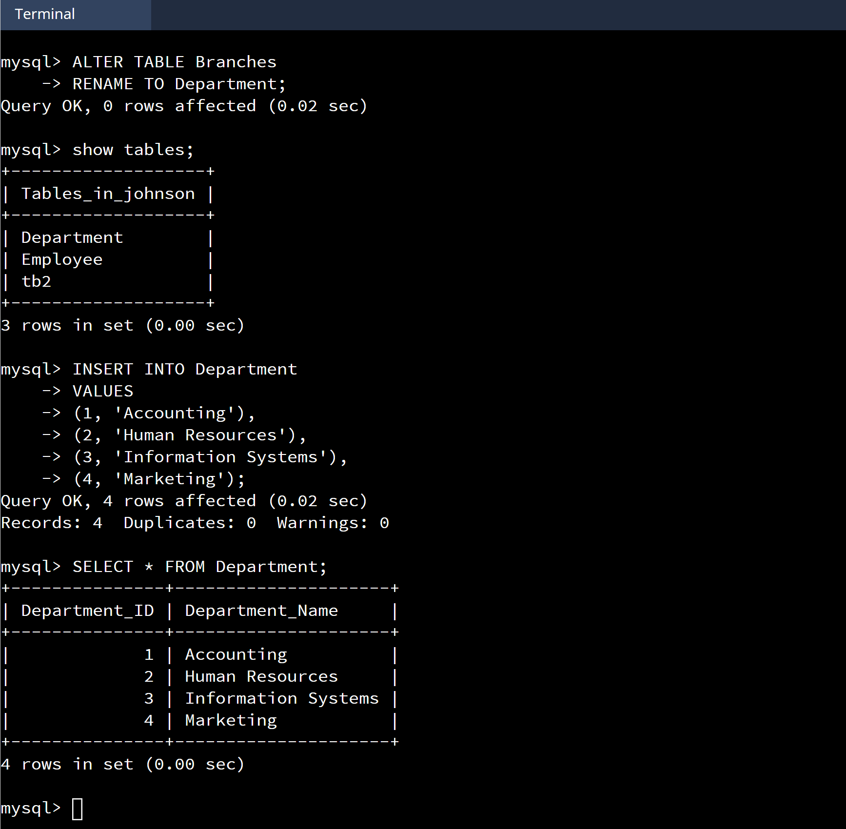

As seen above, the department list is displayed, showing Department names: accounting, human resources, information systems, and marketing.

(c)

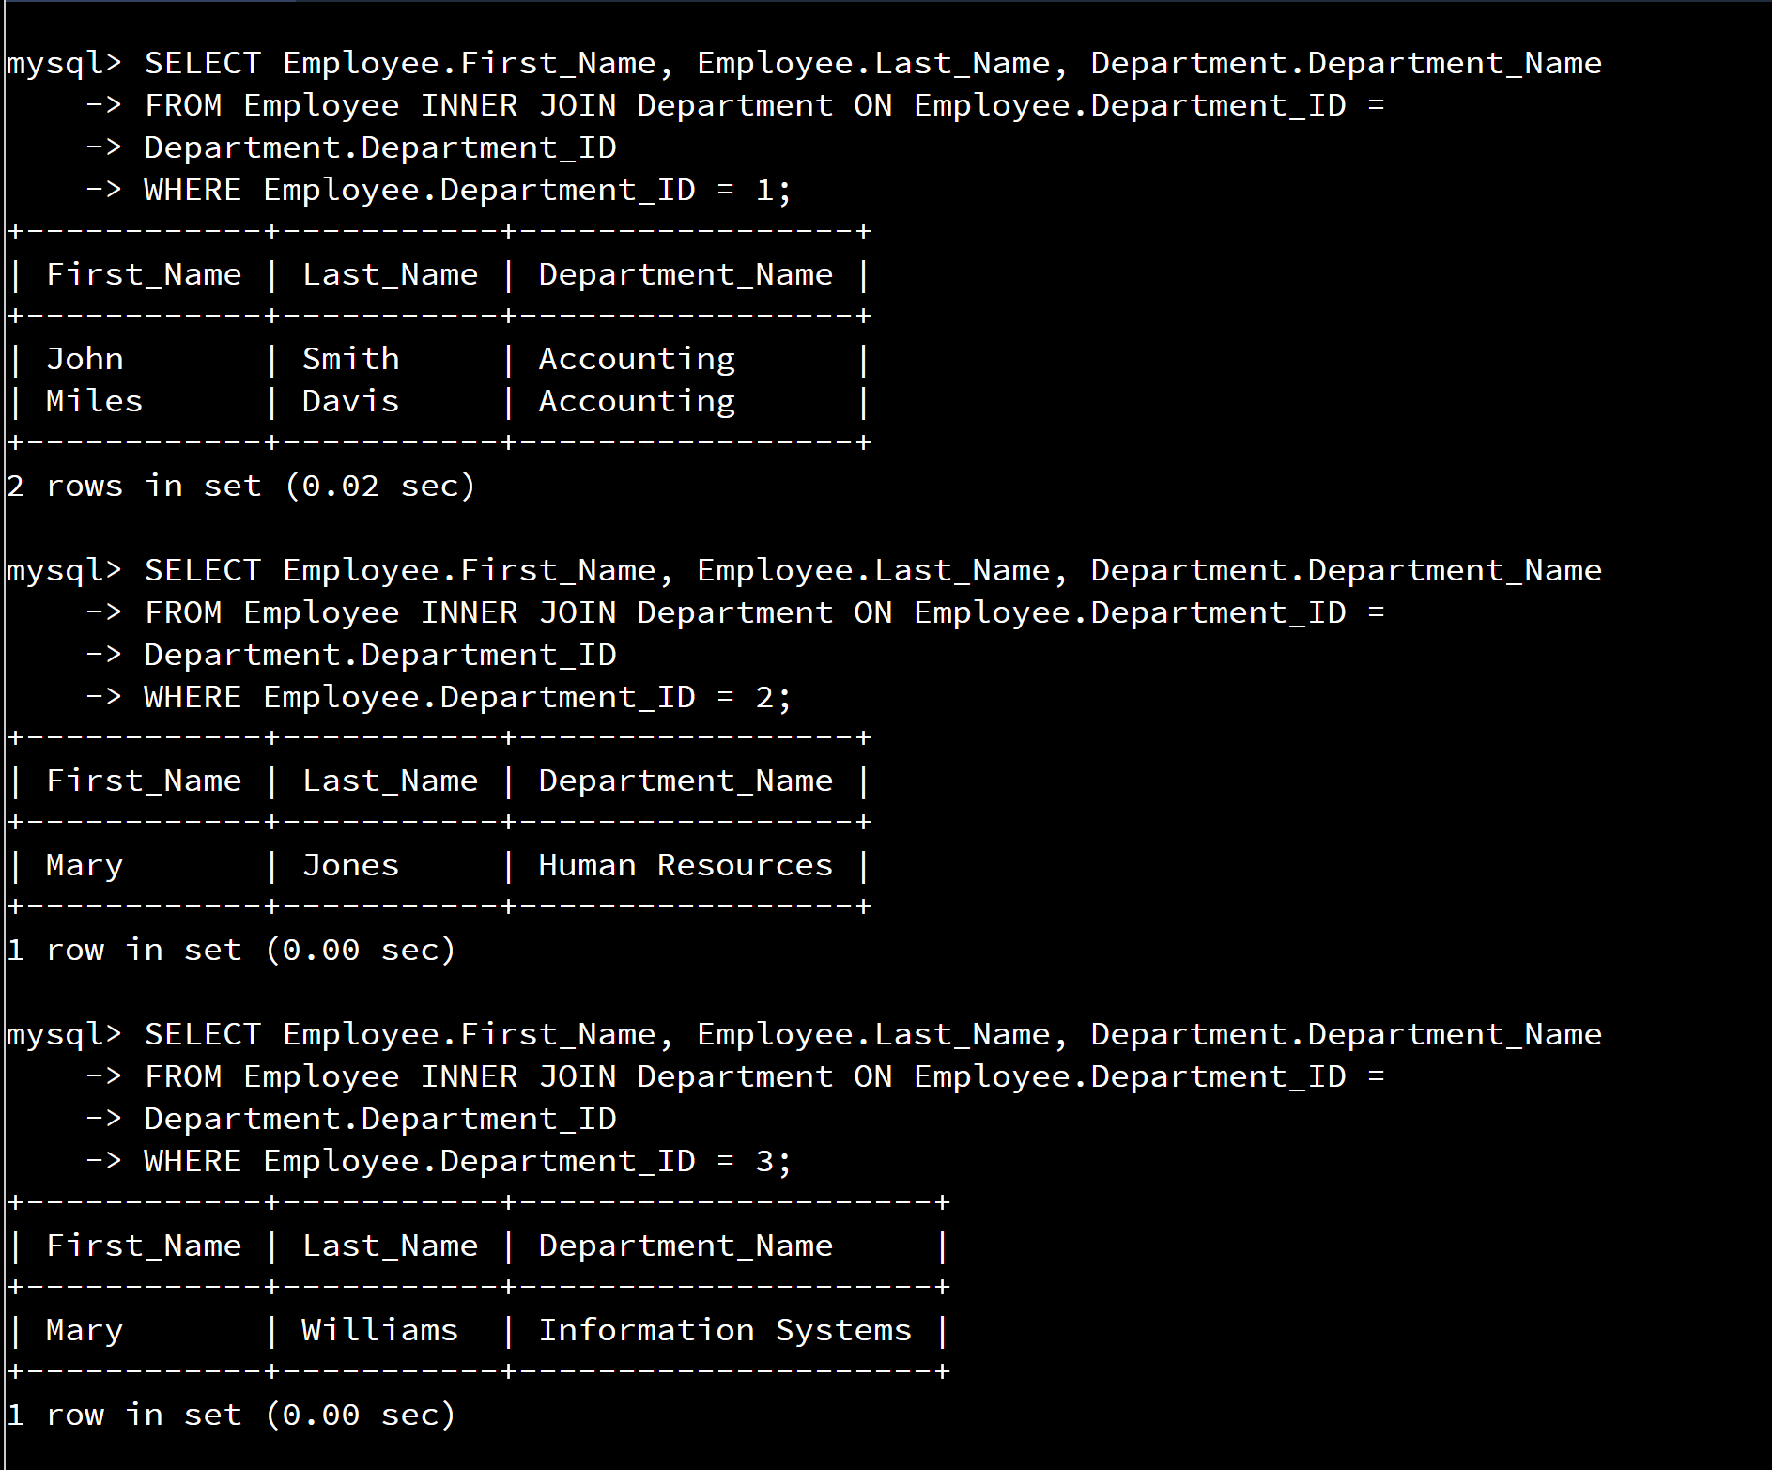

While using INNER JOIN, I was able to display the first and last name of employees entered previously and display them with their department. Mary Williams in the information systems department was done by using the code: **SELECT Employee.First_Name, Employee.Last_Name, Department.Department_Name**

**FROM Employee INNER JOIN Department ON Employee.Department_ID =**

**Department.Department_ID**

**WHERE Employee.Department_ID = 3;**

(d)

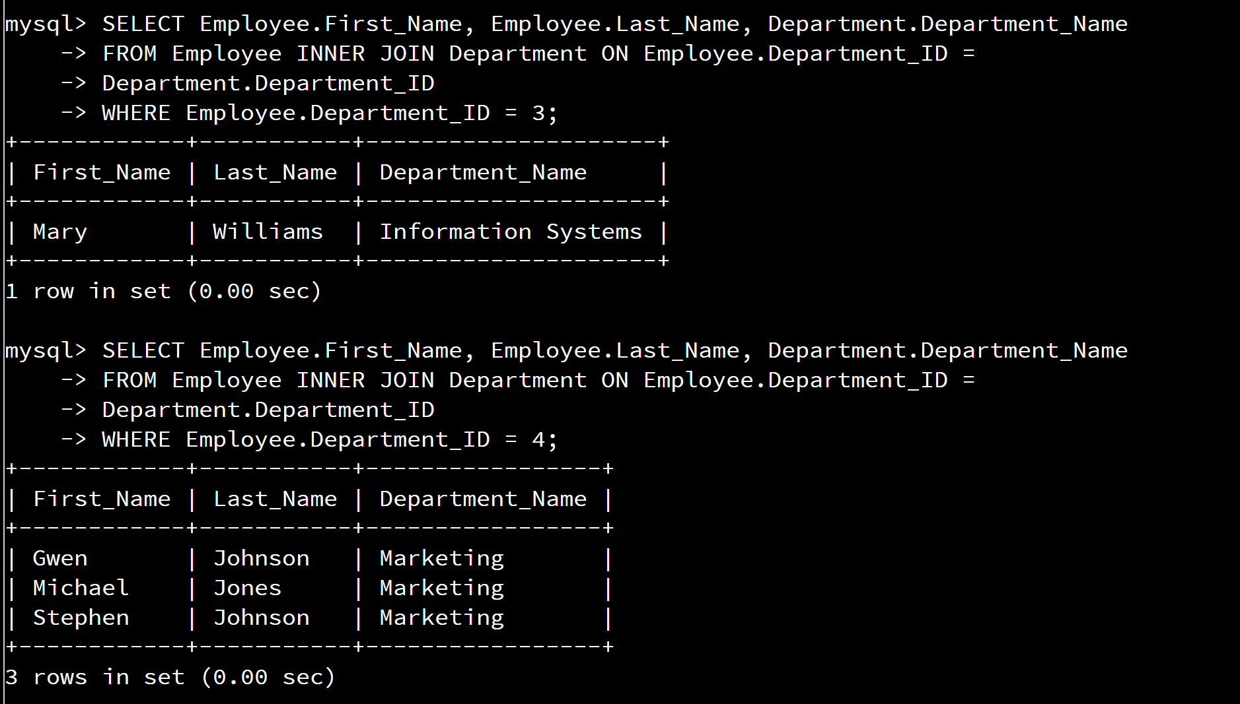

And Gwen Johnson, Michael Jones, and Stephen Johnson with their Marketing department was entered by using the code: **SELECT Employee.First_Name, Employee.Last_Name, Department.Department_Name**

**FROM Employee INNER JOIN Department ON Employee.Department_ID =**

**Department.Department_ID**

**WHERE Employee.Department_ID = 4;**

The accounting and human resources departments were coded with their Department ID’s of 1 and 2 respectively.

(e)

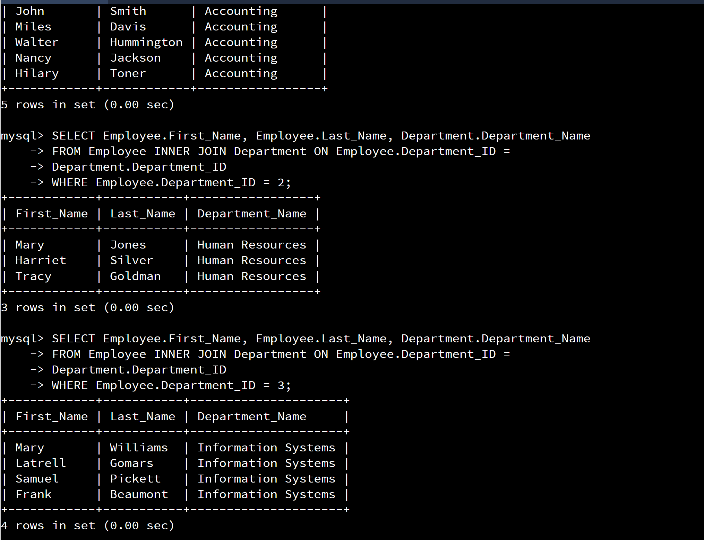

For the additional employees the INNER JOIN was added to complement their addition.

(f)

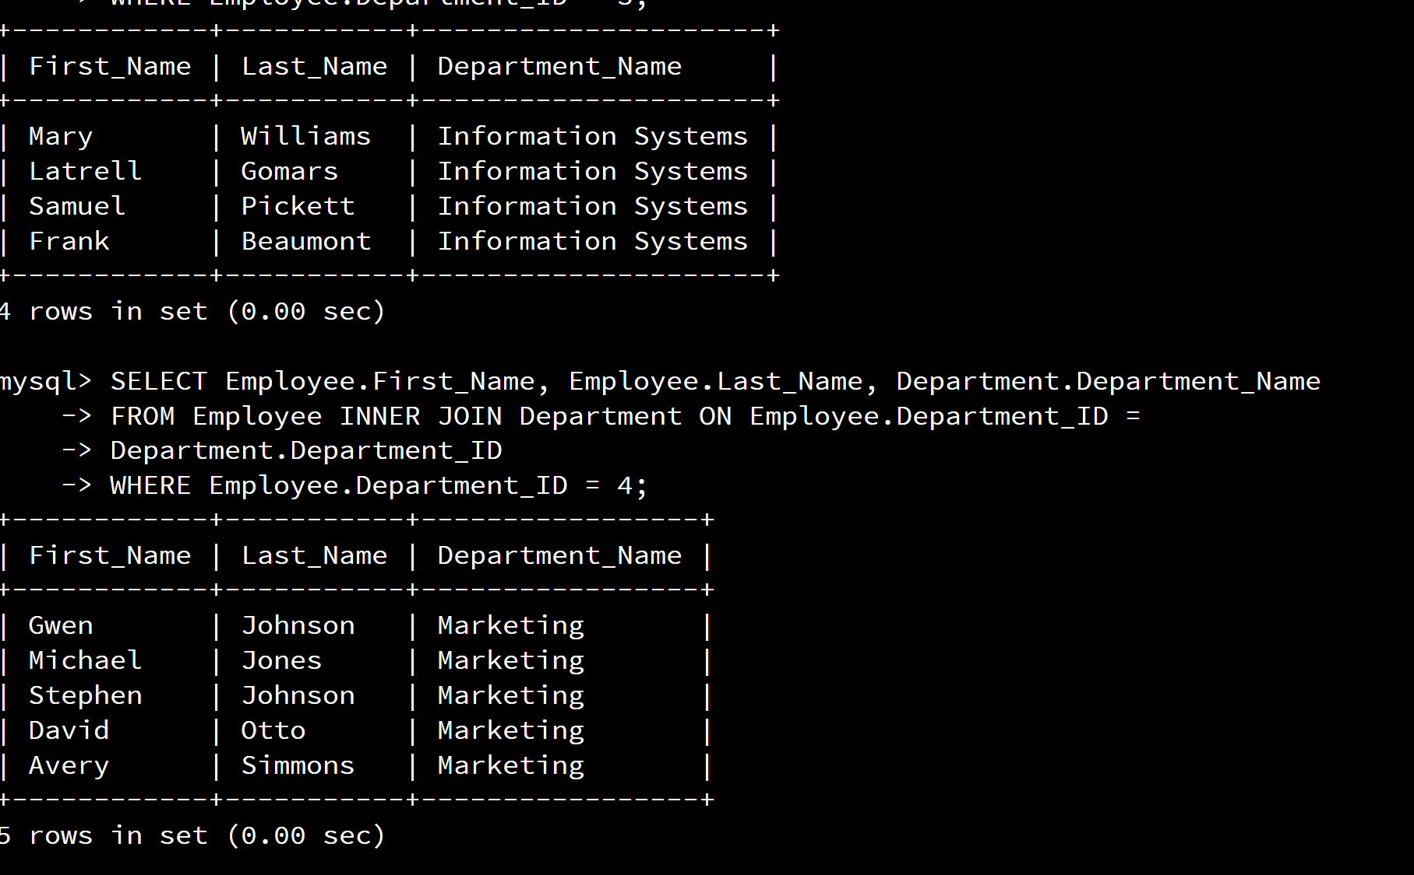

Entering the INNER JOIN included the additional employees as well as the previous employees added last week.

(g)

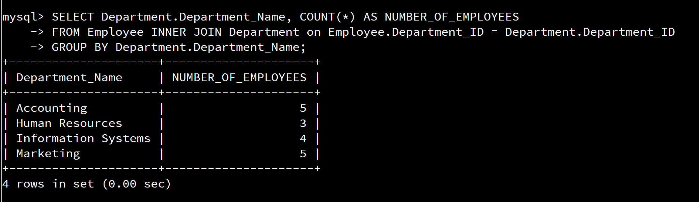

As seen above, we entered the code: **SELECT Department.Department_Name, COUNT(*) AS NUMBER_OF_EMPLOYEES**

**FROM Employee INNER JOIN Department on Employee.Department_ID = Department.Department_ID**

**GROUP BY Department.Department_Name;**

This command retrieved the following: 5 employees in the accounting department, 3 employees in human resources, 4 employees in information systems, and 5 employees in marketing.

(h)

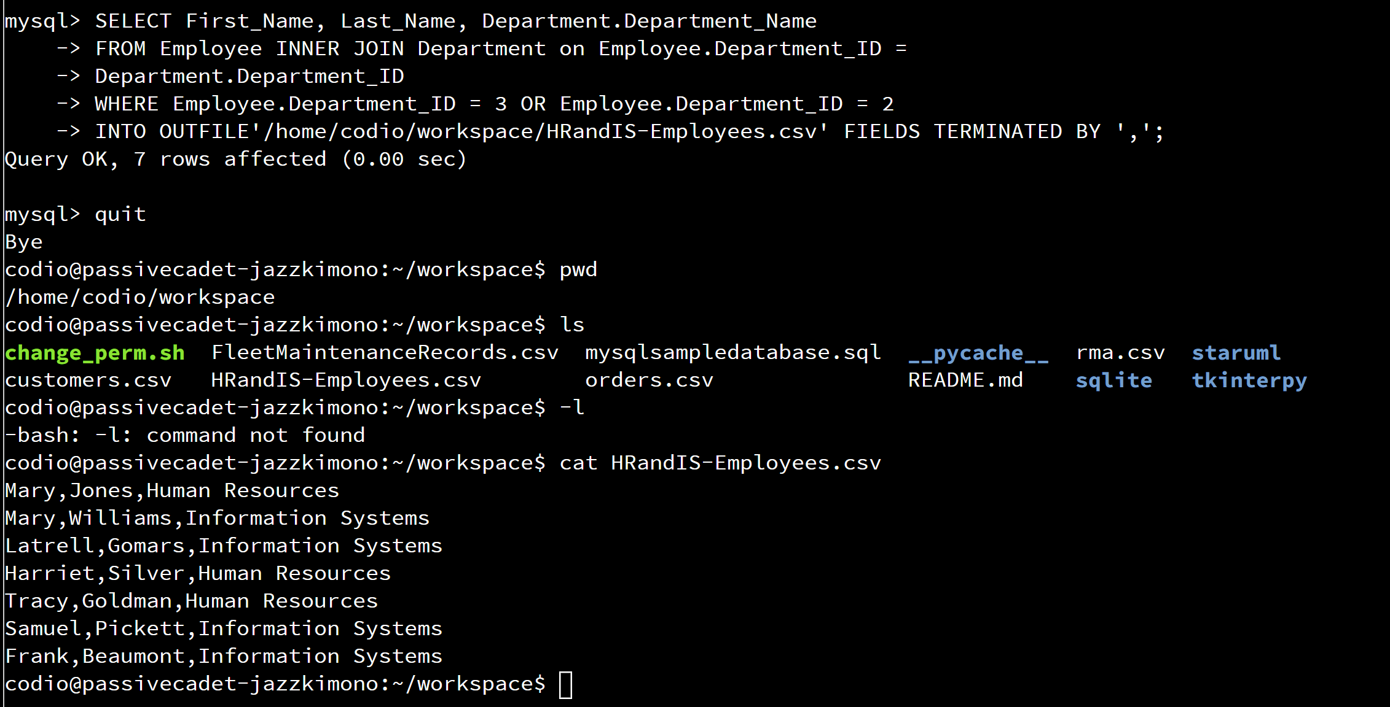

After entering the final command, I had typed **quit** (pressed ENTER) which prints the output to the screen, I typed **pwd** (pressed ENTER) which displays the home directory, then **ls** (pressed ENTER) showing the files contained, and I finally typed **cat HRandIS-Employees.csv** (pressed ENTER).

As seen above, 7 records are in the file when you write the records of your query to a CSV file.